TC-DISP-024
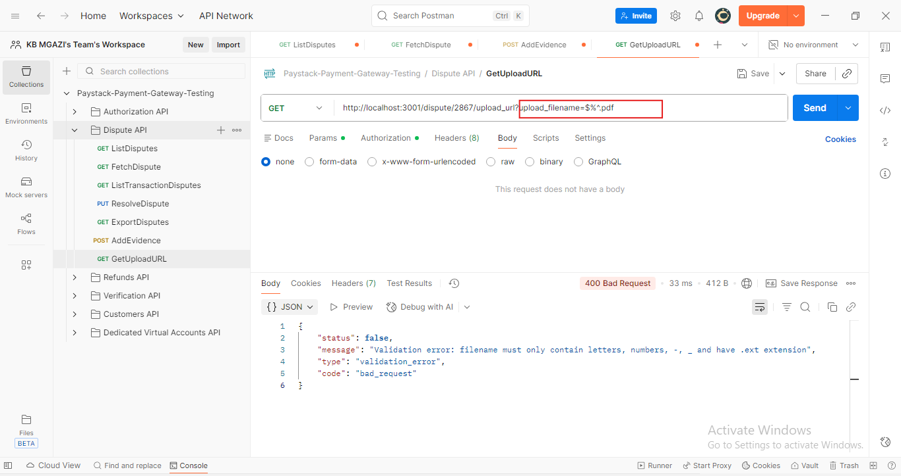
Response:
{
"status": false,
"message": "Validation error: filename must only contain letters, numbers, -, _ and have .ext extension",
"type": "validation_error",
"code": "bad_request"
}

